**Persentation Of Property Analysis Competition Task 2 On Power BI Dashboard**

Page 1:-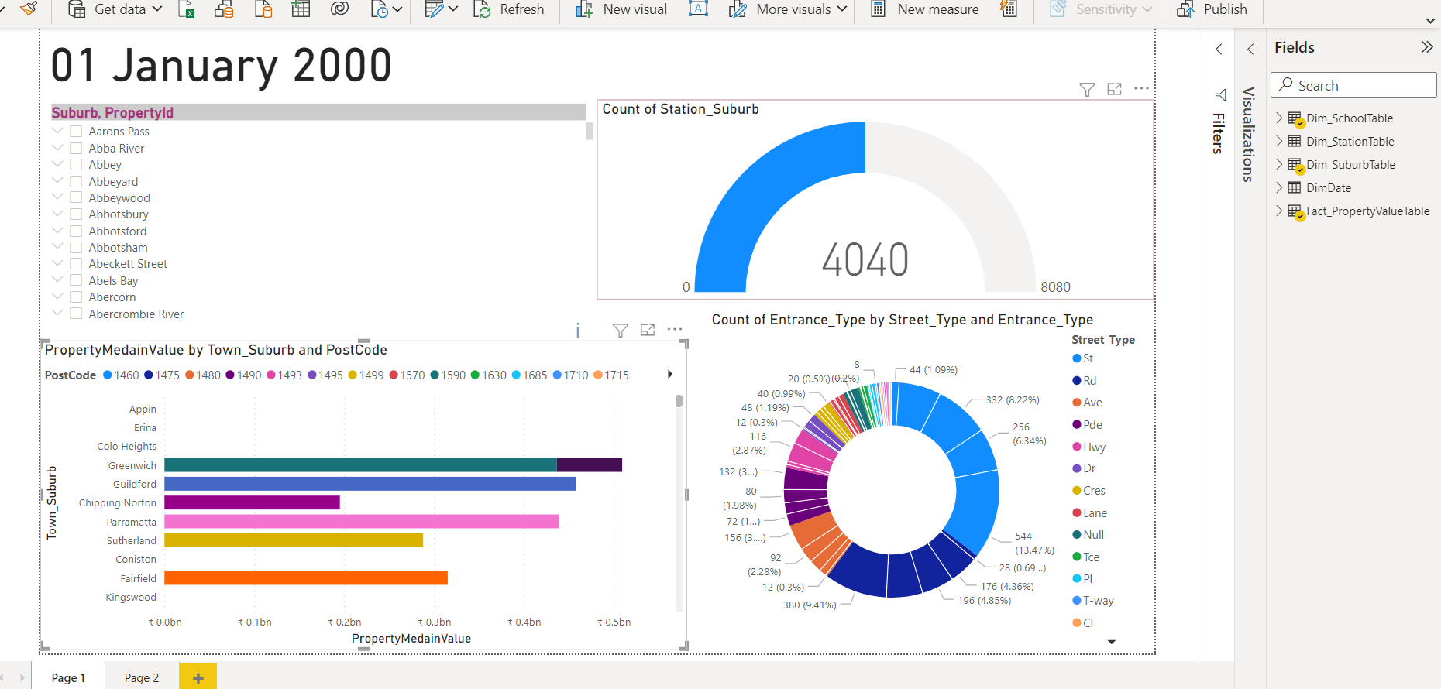

Page 2 :-

